**WEEK -1 : HANDS-ON EXERCISE**

**Data Structures and Algorithms**

**Exercise 7: Financial Forecasting**

**Recursion:**

* Recursion is a technique where a method calls itself to solve smaller subproblems.
* A recursive problem has:
  + Base case: when recursion stops.
  + Recursive case: problem is broken into smaller subproblems.

**Use of recursion:**

* Simplifies problems that have repeating substructure.
* Naturally fits problems like factorial, Fibonacci, tree traversal, etc.

**INPUT:**

**FinancialForecast.java:**

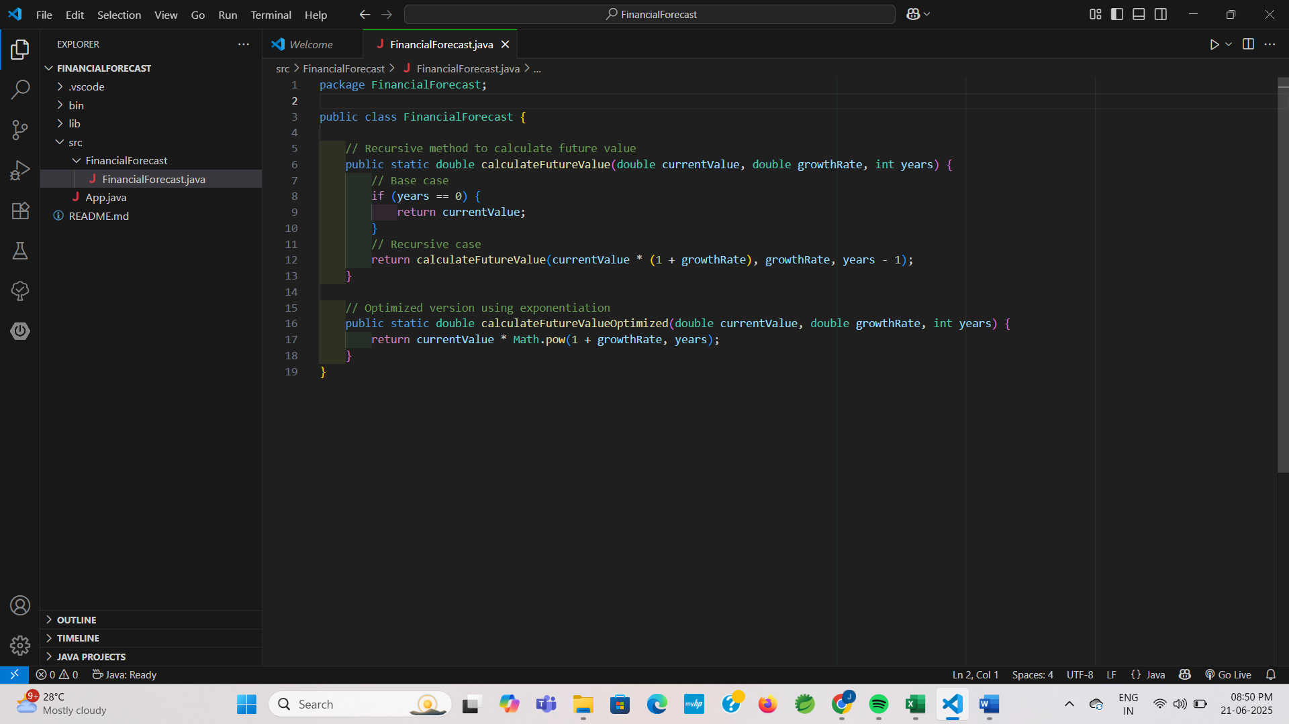

**FinancialForecastTest.java:**

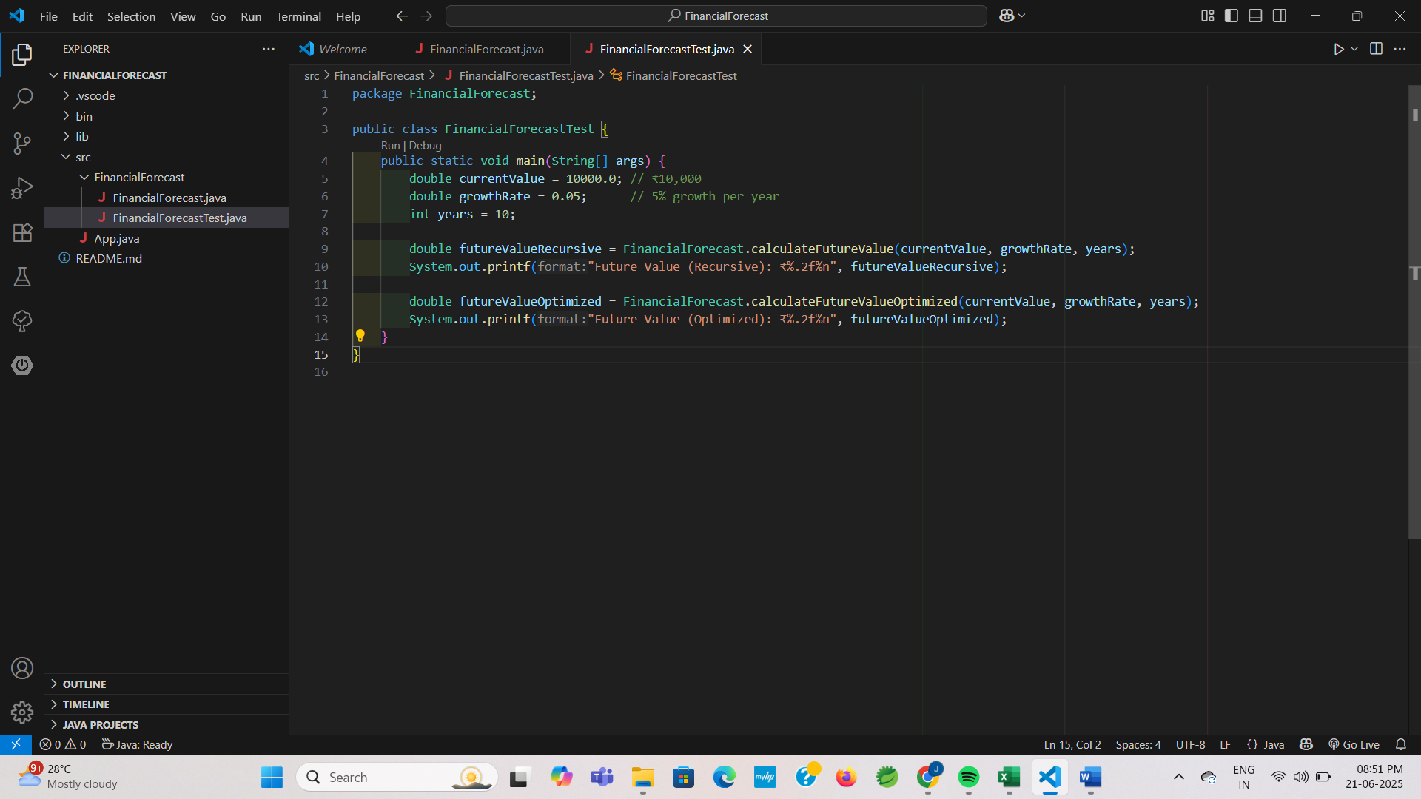

**ANALYSIS:**

|  |  |  |
| --- | --- | --- |
| **Algorithm** | **Time Complexity** | **When to use** |
| Recursive | O(n) | One recursive call per year |
| Optimized | O(1) | Direct calculation without recursion |

**OUTPUT:**

